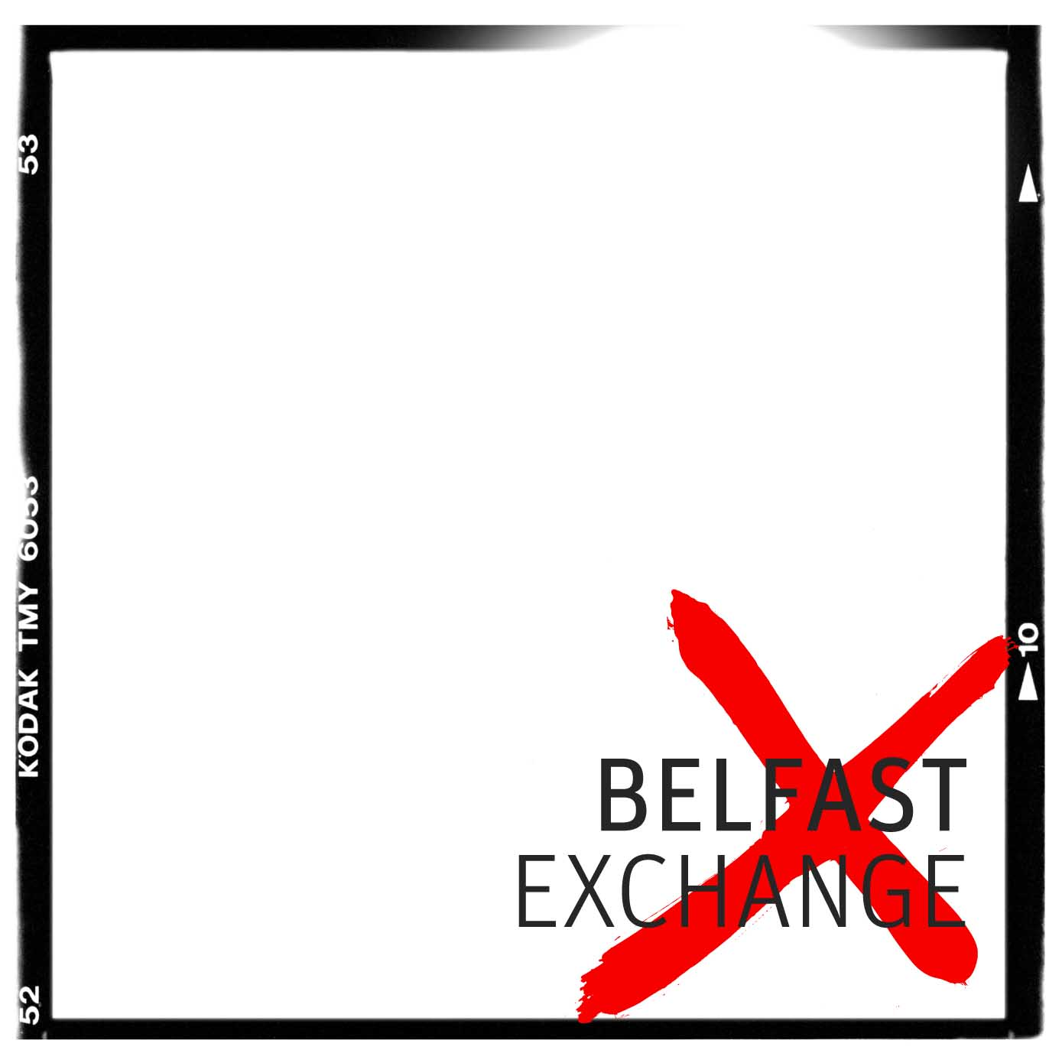

"the soil and the atmosphere…"
a civil history according to
Mervyn Smyth, Sean McKernan, Gerry Casey and others

Opening Sat 07 May / 7-9pm
08 May – 18 Jun 2011

In 1982, a small group of Belfast based photographers initiated an exhibition of photography to be shown in Conway Mill, a community centre in a disused linen mill situated between the Falls and the Shankill. A call for work was sent out, with entry open to “any amateur photographer who wishes to explore any aspects of the city or its people." The exhibition was called ‘Belfast Exposed’.
Belfast Exposed, as the group itself came to be known, showed work from predominately young, working class perspectives on both sides of the divide. Opening the exhibition at the Bank of Ireland Gallery, Dublin in 1984, Seamus Heaney remarked on the “powerful, democratic feel running through these photographs” which documented a common experience of unemployment, poor housing and economic deprivation, at once intensified by the effects of conflict and alleviated by the gritty humour of working class Belfast life.
Using photography to challenge mainstream representation of community experience, Belfast Exposed offered a platform for local people to tell their own stories. Over the years, the group continued to produce and exhibit images taken by participants on community projects as well as their own documentary images of more overtly 'newsworthy' political activity. In the archive, photographs of boys playing football, courting couples and families eating Christmas dinner sit alongside riots, rallys and funerals, often on the same contact sheet. In the backgrounds, a record of change in fashions, the dominant sub-cultures and social movements, changes in the urban fabric of a place scarred by civil unrest.

The archive represents the city at a revolutionary moment, when a resilient population carried on with their lives against a backdrop of radical change and often harrowing violence. Born out of a strong photo-journalistic ethic, rooted in everyday experience, thirty years on Belfast Exposed remains a space for production, learning and the exchange of ideas, a place where people, politics and photography meet.
This selection of images from the collection and extracts from previously commissioned essays, reflects upon the aesthetics of protest and revolution, the power of photography to give individuals a voice and illuminates lived experience within the historical moment. Under headings of The City, Trades and Industries, Community Arts and Political Players, we celebrate the city of Belfast and the people who have shaped our understanding of it.

We would like to thank the original photographers - Sean McKernan, Mervyn Smyth, Gerry Casey and all other contributing photographers to the archive. Copyright of the original archive material remains with these photographers and with Belfast Exposed.

